

LAB REPORT

**CSE4020 – MACHINE LEARNING LAB**

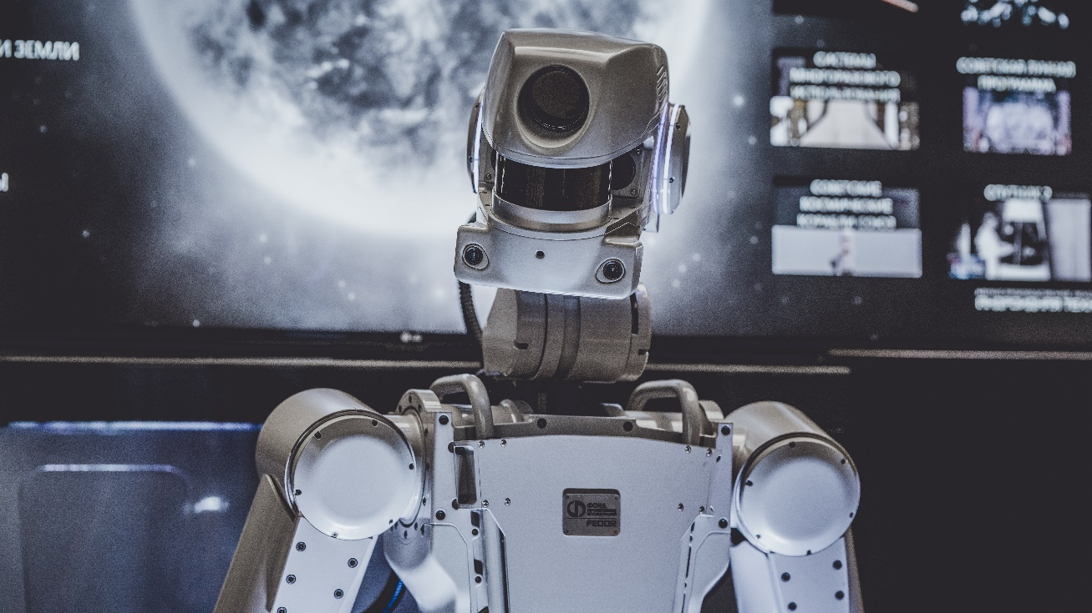

**(B.Tech. Computer Science Engineering)**

**FALL SEMESTER 2021-2022**

|  |  |
| --- | --- |
| **Name:** | ALOK MATHUR |
| **Reg. No:** | 20BCE2959 |
| **Slot:** | L45+L46 |
| **Faculty Name:** | JAISANKAR N SIR |

**VIT – A Place to Learn; A Chance to Grow**